Publication order form

Order confirmation
No. | Item |  | 5 copies: $7.50 | 10 copies: $17 | 20 copies: $20
1 | Sick day management type 1 consumer resource | 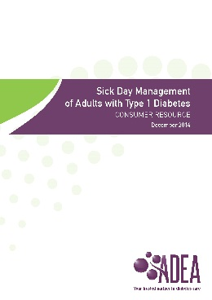
2 | Sick day management type 2 consumer resource | 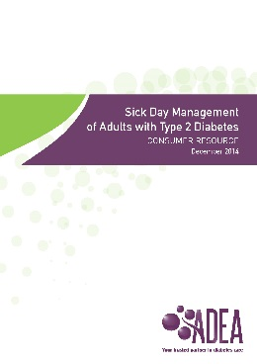
Total

Payment options
Payable to Australian Diabetes Educators Association (ADEA) ABN 65 008 656 522
Credit Card: Master Card Visa Amount: $
Name on card: Expiry Date: __ __ / __ __
Card number: __ __ __ __ __ __ __ __ __ __ __ __ __ __ __ __
Signature: Date __ __ / __ __ / __ __
Invoice Amount: $
Name:
Email: Phone:

Delivery details
Title: First name: Last name:
Address (no PO Box please):
State: Suburb: Postcode:
Email: Phone:

Please complete and return this order to
Scan and email: inquiries@adea.com.au
Fax: 02 6287 4877
Post: Australian Diabetes Educators Association, PO Box 163 Woden ACT 2606

Note
- All charges include GST and postage and handling.
- A credit card surcharge will be applied.
- Please allow 2 weeks for delivery of these items.
- Receipts will be provided for each purchase via the provided email address.
- For further assistance, please email inquiries@adea.com.au.

